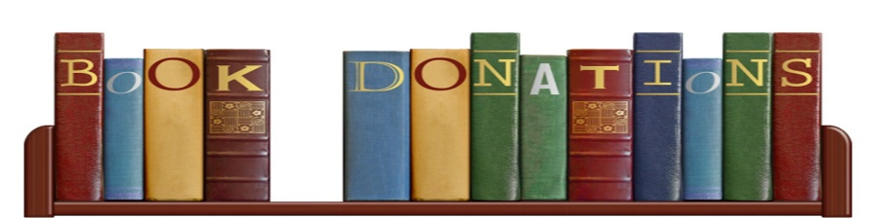

Recycle Your Children’s Books!
The Friends of the Salem Library are asking for donations of gently used children’s books.
The collection days will be at the yellow Zemko Garage @ 230 Hartford Rd., Salem, CT:
Saturday, May 22, 2021 from 9 a.m. to 3 p.m.
Saturday, May 29, 2021 from 9 a.m. to 3 p.m.
Please separate the books into three categories:
Picture books, chapter books and non-fiction.
No dirty, torn, old or otherwise damaged books, please.
Before you donate, ask yourself, “would I buy this book?”

Questions: Contact Carl Nawrocki at carlybilly@aol.com
The children’s book sale will take place on
Saturday, June 19, 2021 from 9:00 a.m. to 3:00 p.m.
@ the Town Pavilion, 89 Norwich Rd., Route 82, Salem, CT.

