COVID-19 Post-Test Information

What kind of COVID-19 test did I receive?
Sema4 took a nasal swab from you, which we will test in our laboratory for SARS-CoV-2, the virus which causes COVID-19. We use a highly accurate technique called Polymerase Chain Reaction (PCR) to look for the virus in your swab sample.

When will I get my results?
You will receive your results in 24-48 hours from the time we receive your swab.

How will I get my results?
Your results will be available in the Sema4 Patient Portal.

How do I register for the Sema4 Patient Portal?
Before being swabbed, you will be asked to provide a valid email address. Once your swab arrives at our lab, you will receive an email with instructions for logging into the Sema4 Patient Portal to create an account. Please note that each individual tested will need to provide a unique email address.

What if I don’t have an email address?
If you do not have an email address, you can supply a cell phone number. Once your swab arrives at our lab, we will send you a text message with instructions for logging into the Sema4 Patient Portal to create an account. Please note that each individual tested will need to provide a unique email address or phone number.

What if I need to register a minor?
Legal guardians or parents must provide an email address or cell phone number to register a minor on the Sema4 Patient Portal. Children must be registered using a unique email address or phone number (i.e., a parent and child cannot use the same contact information).

How do I access my results in the Sema4 Patient Portal?
After your sample has been processed, you will receive another email notifying you that the results are ready. You can then access your test results via the Sema4 Patient Portal, as well as downloading a PDF copy of your results for your records.

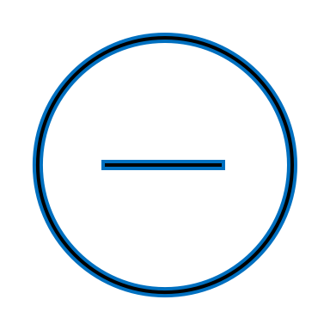

What should I do if I feel ill before getting my results?
If you feel sick before getting your results, you should self-isolate right away to protect others. If you feel very ill, please contact your healthcare provider. In an emergency, please call 9-1-1.

What happens if I test positive?
If you test positive, please contact your healthcare provider. Even if you do not have symptoms, the CDC recommends that you stay home, isolate yourself from others, and wear a mask over your nose and mouth. For a full list of recommendations, please visit:
https://www.cdc.gov/coronavirus/2019-ncov/if-you-are-sick/steps-when-sick.html

What happens if I test negative?
If you test negative, you should continue to practice social distancing and wear a mask. Just because you are negative now does not mean you will stay negative.

How accurate was the test I received?
The clinically-validated PCR tests used by Sema4 have achieved the highest level of sensitivity (100% at 60 copies/ml) and specificity (>99%) available for these types of COVID-19 tests. We run them in our CLIA-certified and CAP-accredited laboratory in Branford, CT.

What is Sema4?
Sema4 is a patient-centered health intelligence company advancing healthcare through data-driven insights. As one of the leading clinical genomics labs in the world, Sema4 provides reliable and accurate COVID-19 results within approximately 24-48 hours. We are headquartered in Stamford, CT.

Who can I contact if I need more information or have questions?
Sema4 is here to help you with any questions you have. Please call our Client Services Team at 800-298-6470 and then press “5” or email us at Cov2support@sema4.com

